David Bojorquez
Alec Rosales
Israel DeLaTorre

How to make a Camera Obscura
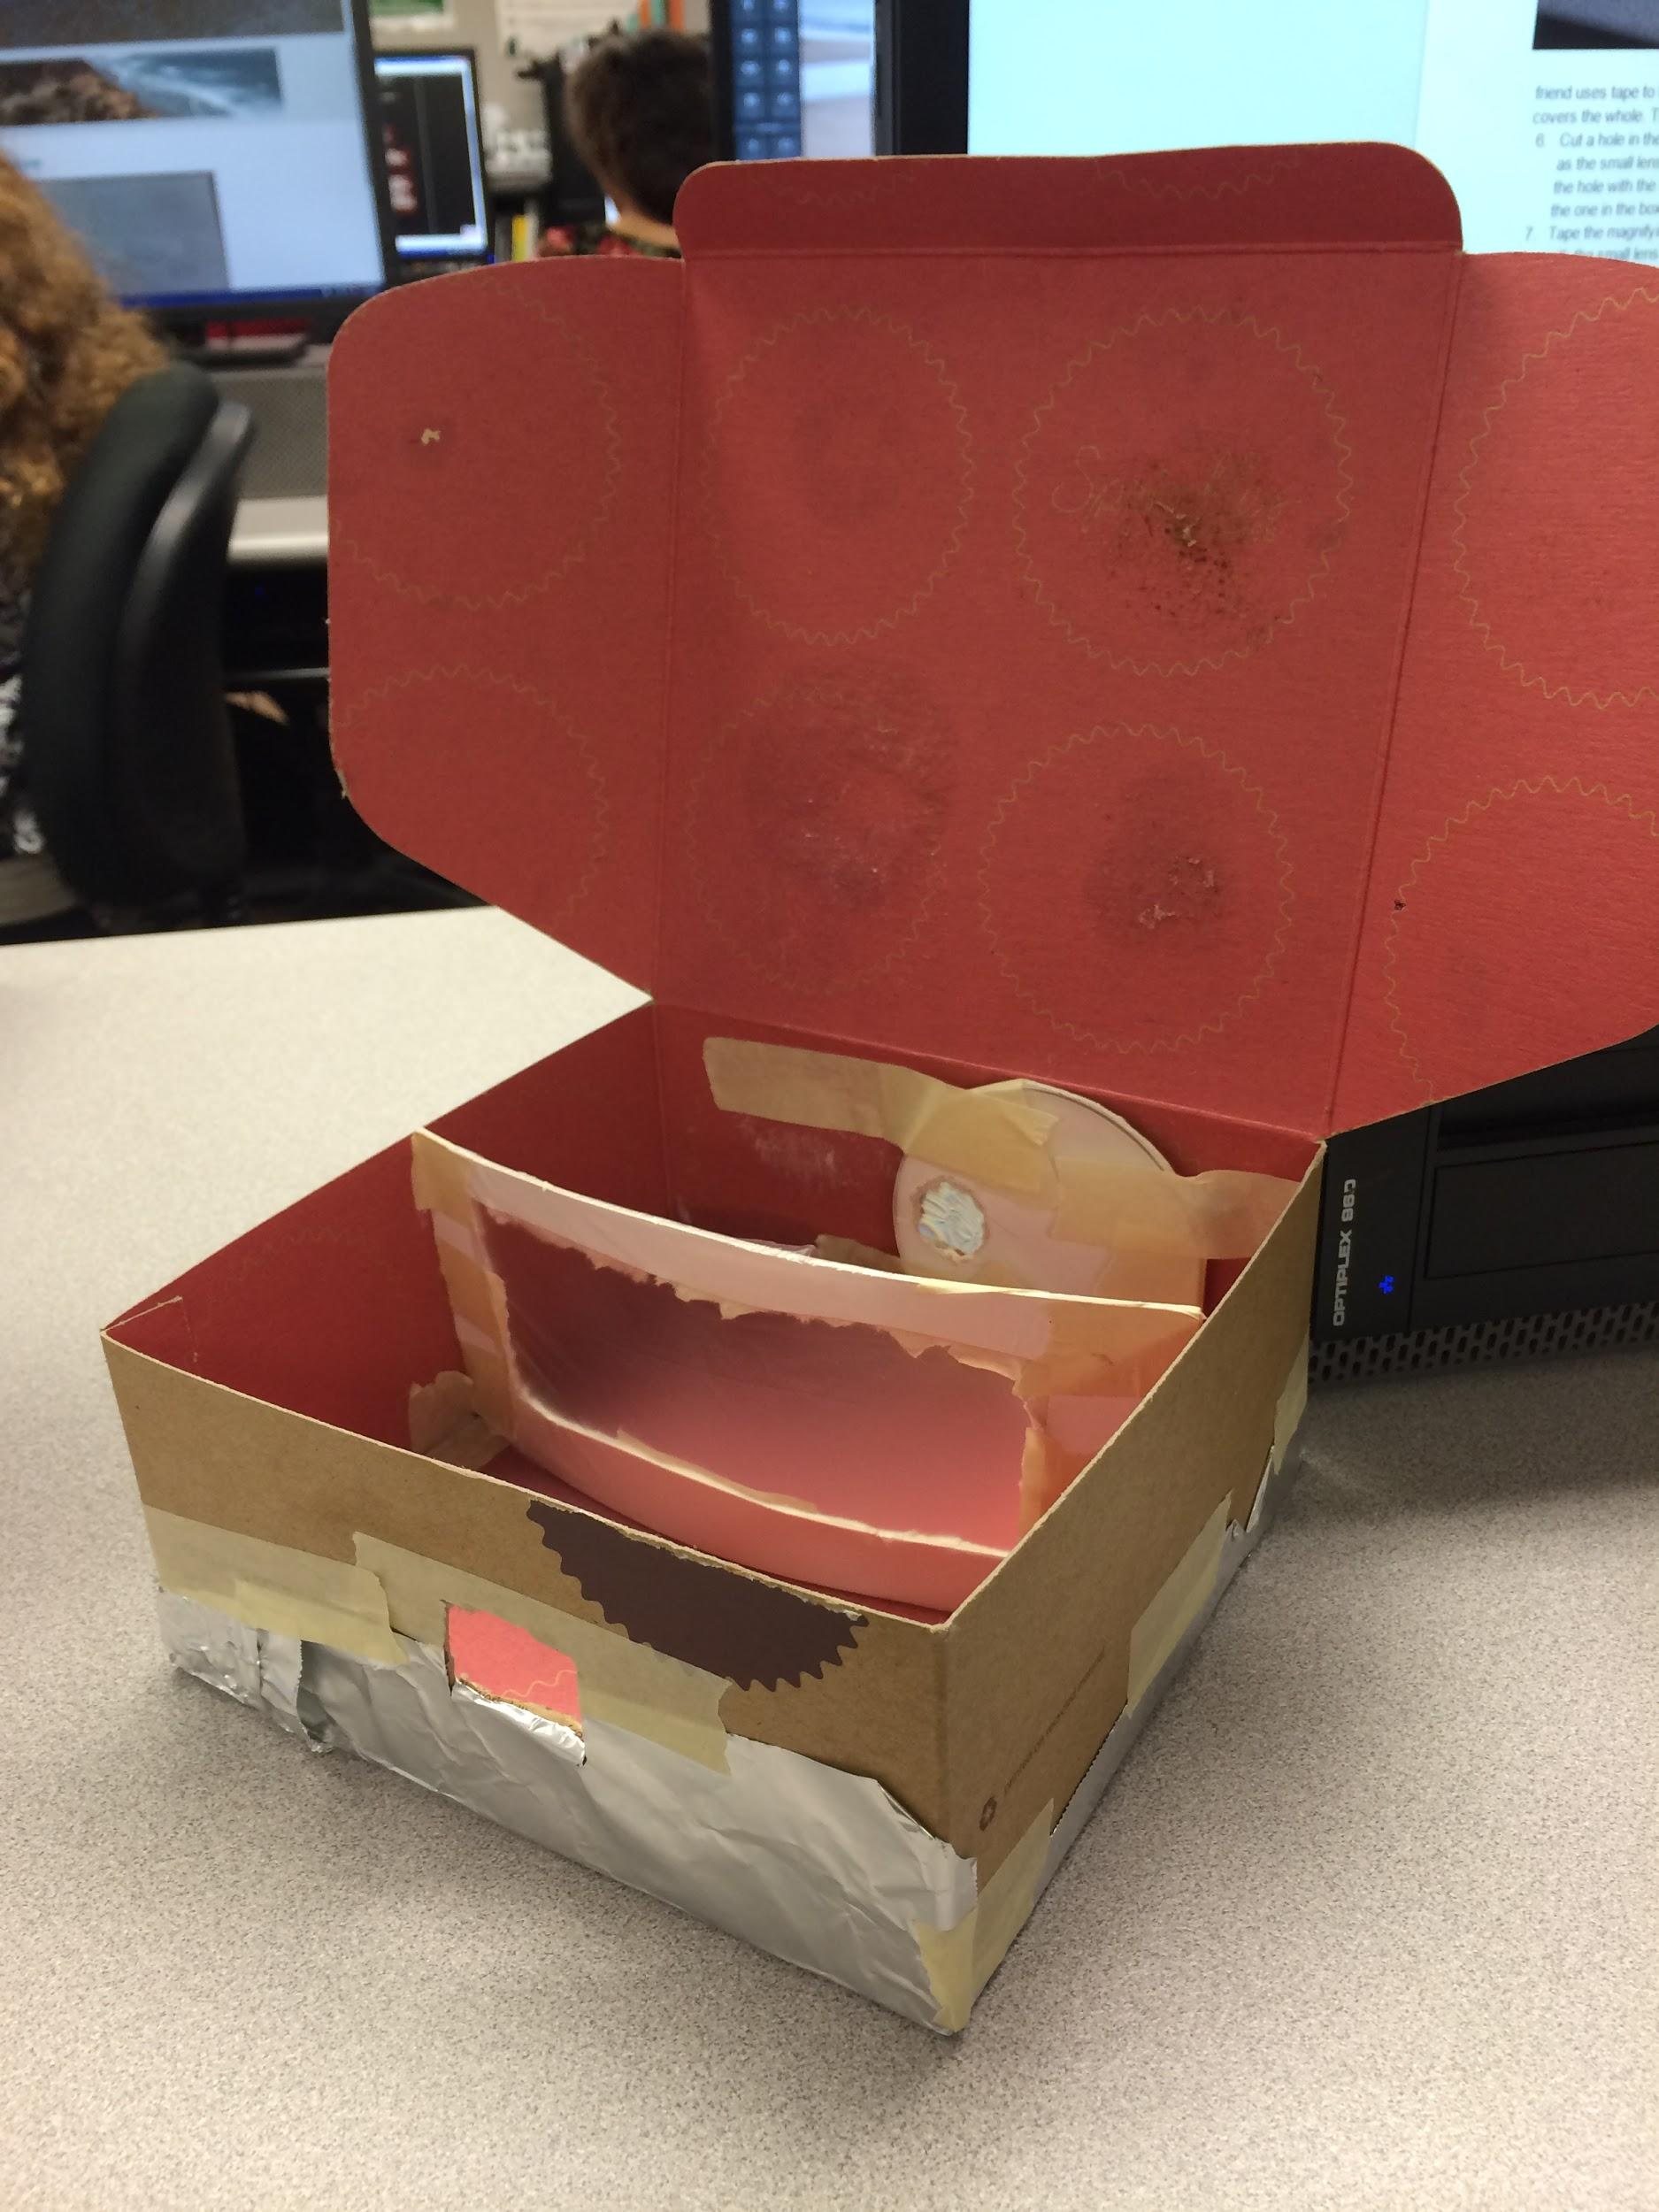
Materials:
- Box
- Construction Tape
- Magnifying Glass ( One with
- Tough construction sheets
- Clear Grocery bag
- Tin foil.
- Scissors
- Exacto knife
- Pencil

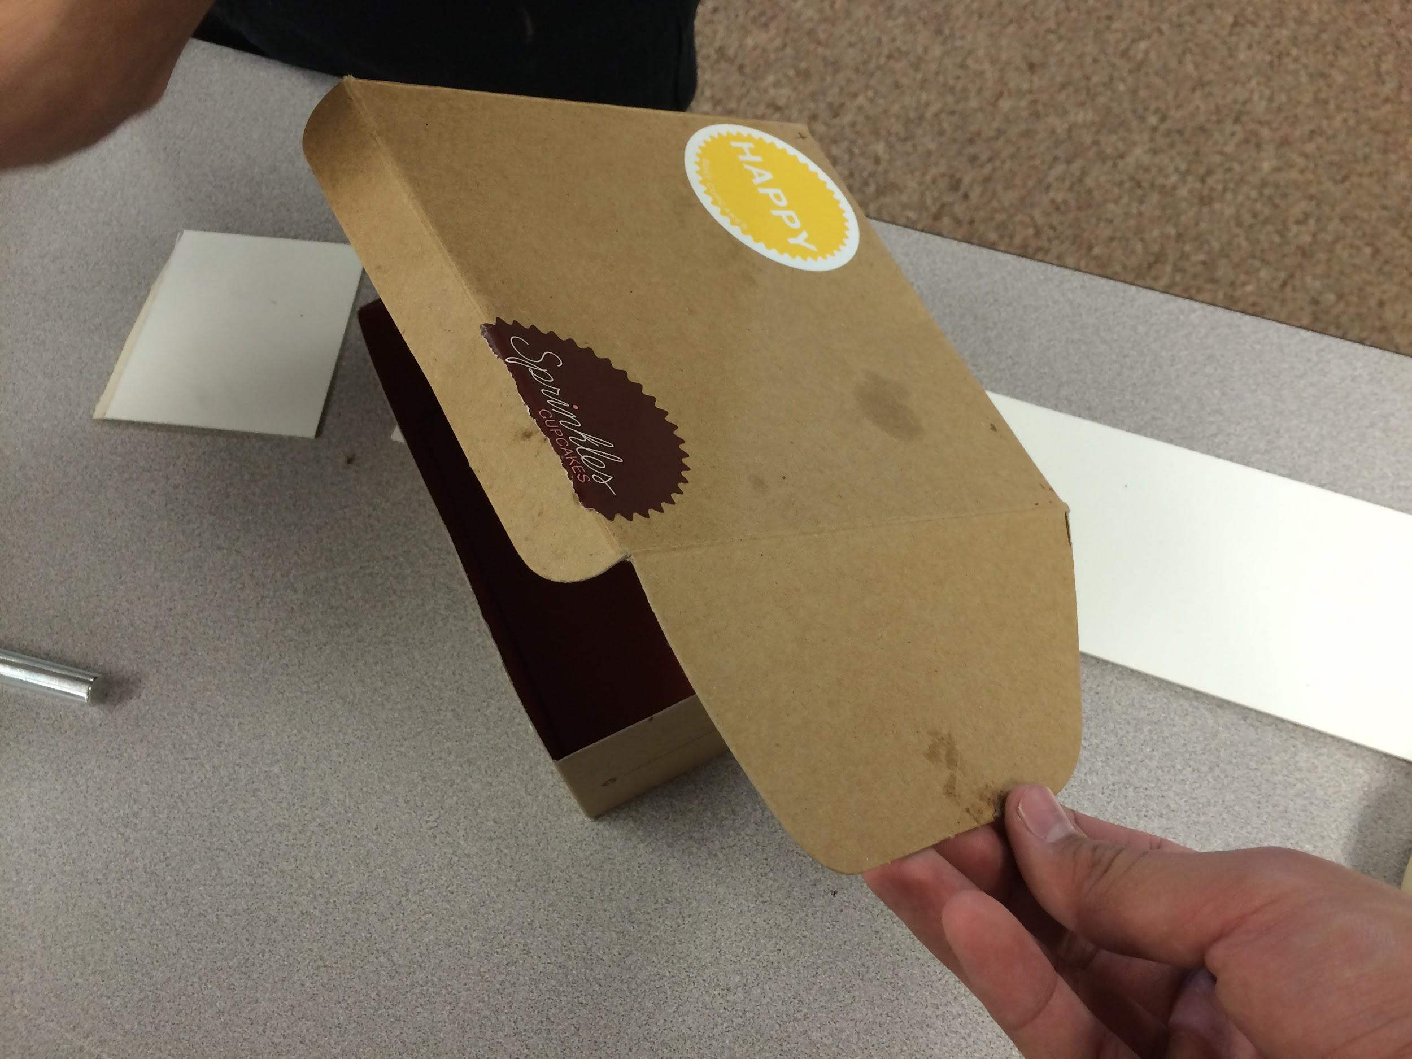
Steps:
- Use tape and tin foil to cover any unintended holes in the box preventing light from passing through. Note: This does not include the lid and flaps of the box.
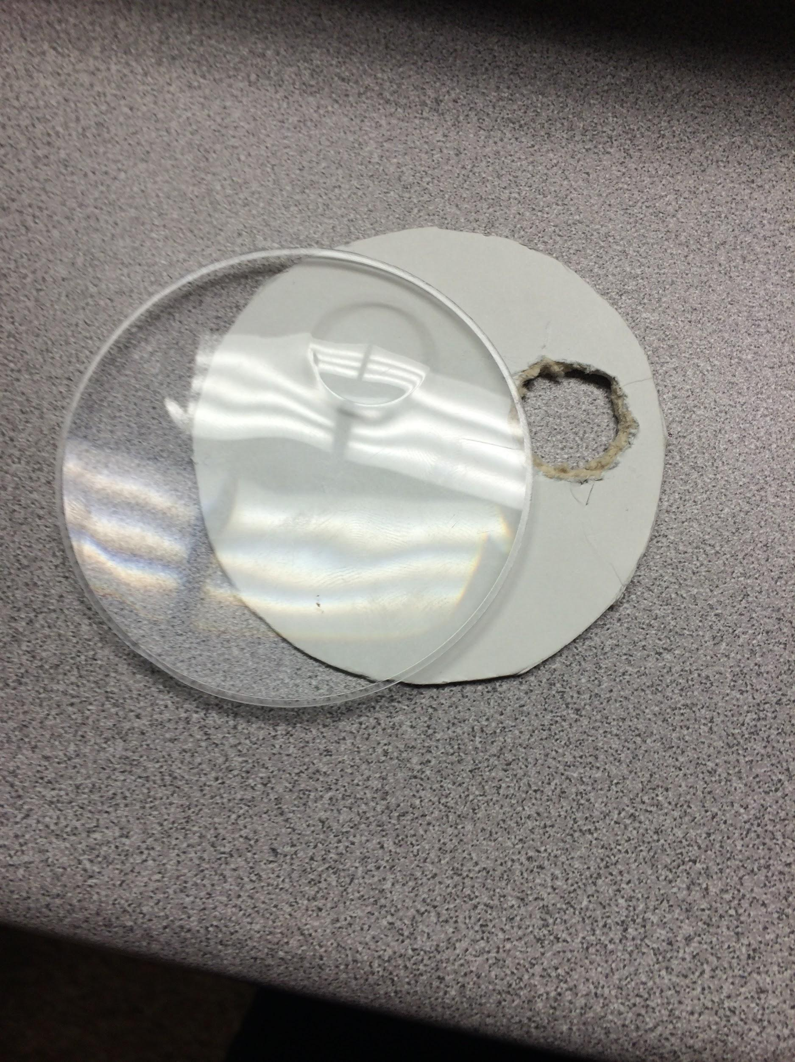
- Remove the glass from your magnifying glass and place it on top of one construction sheet. Trace a circle around the glass and cut along the line. Make another circle the same size and on the same spot on the paper circle as on the magnifying glass
- Grab another piece of tough construction paper and cut it to be the same height and just a small length (about ¼ cm) then the length of the box.
- Cut out a rectangular hole in the center of the new card.
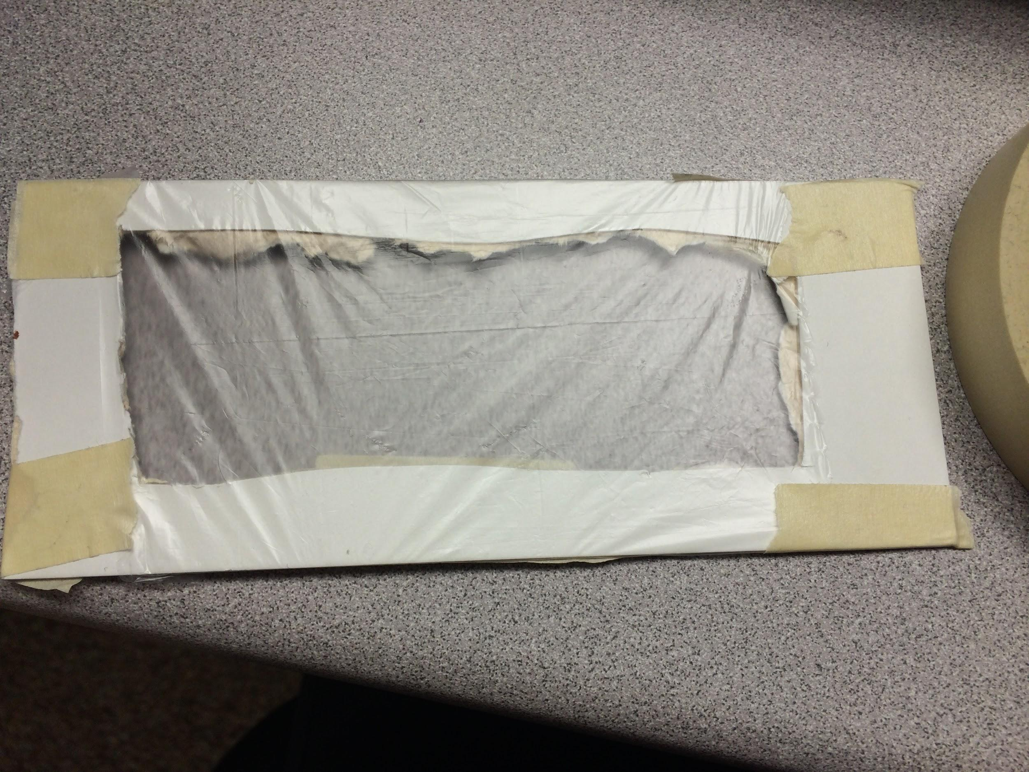
- Cut a piece of the clear grocery bag a little larger than the cut hole in the card. Hold the bag tightly over the picture while a friend uses tape to tape the plastic to the card. Make sure the plastic is tight as it covers the whole. This will act as your frame.
- Cut a hole in the far end of the box the same size as the small lens. Tape the white circular card over the hole with the hole in the card overlapping with the one in the box on the inside of the box.
- Tape the magnifying glass over the circular card with the small lens aligned with the hole in the card and box.
- Place the frame facing the camera inside the box. it should bend a little and fit snugly.
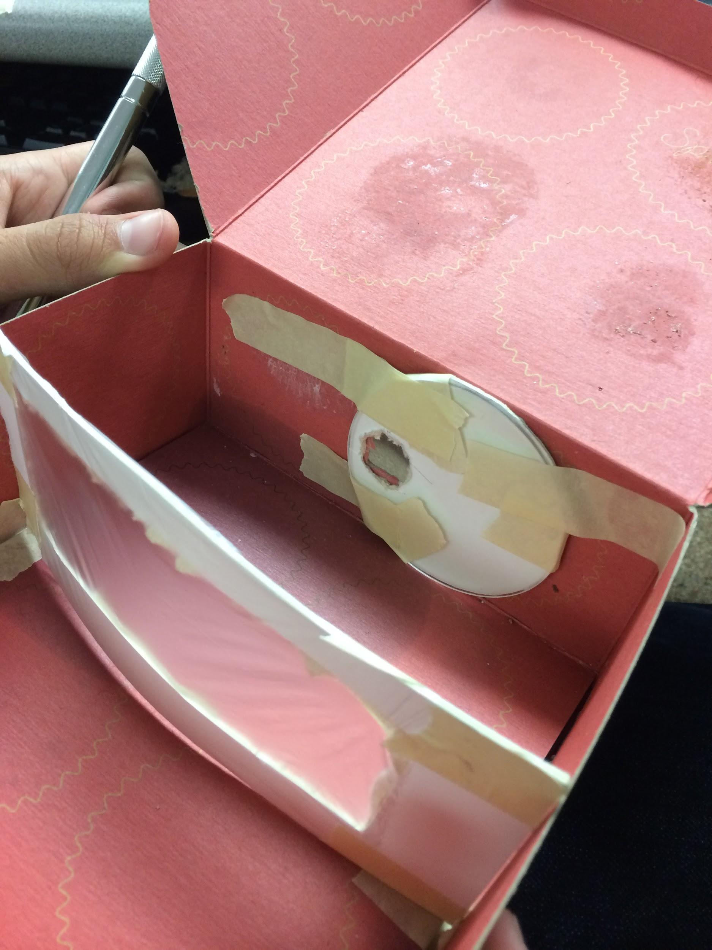
- Cut a small square hole in the opposite far end of the box.
- Close the lid tightly and enjoy!*
Note: if the image is blurry adjust the frame by moving it closer or farther from the lens.

